(K8S) Kubernetes Task -03

- Create a ClusterIP service for an Apache web server pod.
- Expose an Nginx pod externally using a Node Port service.
- Deploy a Replication Controller to maintain 3 replicas of an Nginx pod.
- Scale the Replication Controller from 3 replicas to 5 replicas.
- Create a ReplicaSet to manage pods based on multiple labels (prod and test).
- Deploy a ReplicaSet that excludes pods with the label backend.
- Test load balancing across multiple pods using a NodePort service.
- Delete a Replication Controller without affecting the running pods.

- Create a ClusterIP service for an Apache web server pod.

1. Create Apache Pod
kubectl run apache-pod --image=httpd --port=80
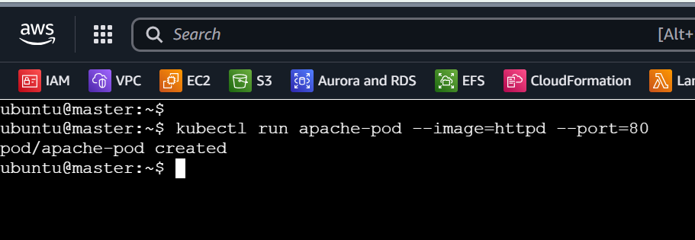

2. Check the Pod
kubectl get pods
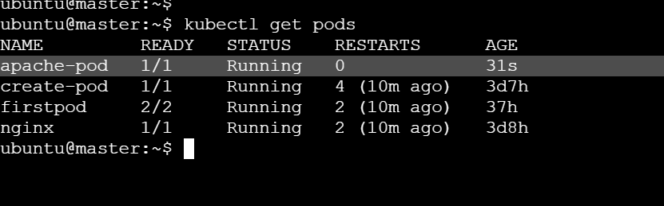

3. Create ClusterIP Service
kubectl expose pod apache-pod --name=apache-service --port=80 --target-port=80 --type=ClusterIP
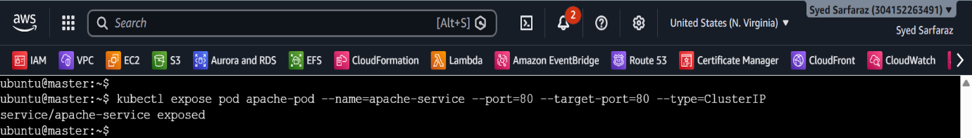

4. Check the Service
kubectl get svc apache-service
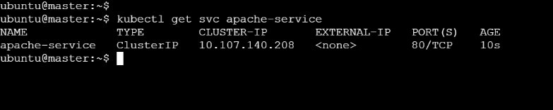

5. Verify the Service Endpoint
kubectl get endpoints apache-service
Expected: You should see the Apache pod's IP listed as the service endpoint.
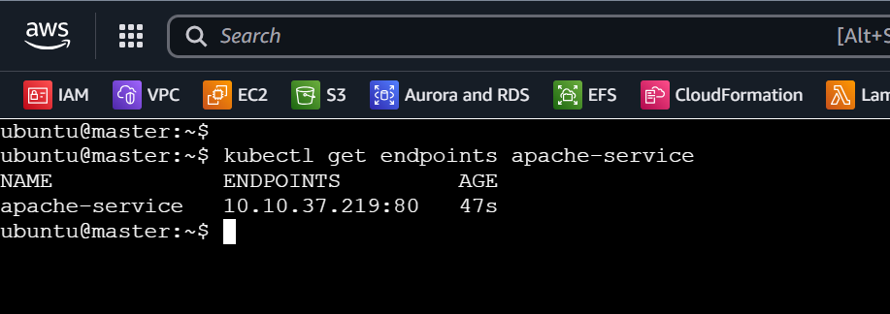

- Expose an Nginx pod externally using a NodePort service.

1. Create Nginx Pod
kubectl run nginx-pod --image=nginx --port=80
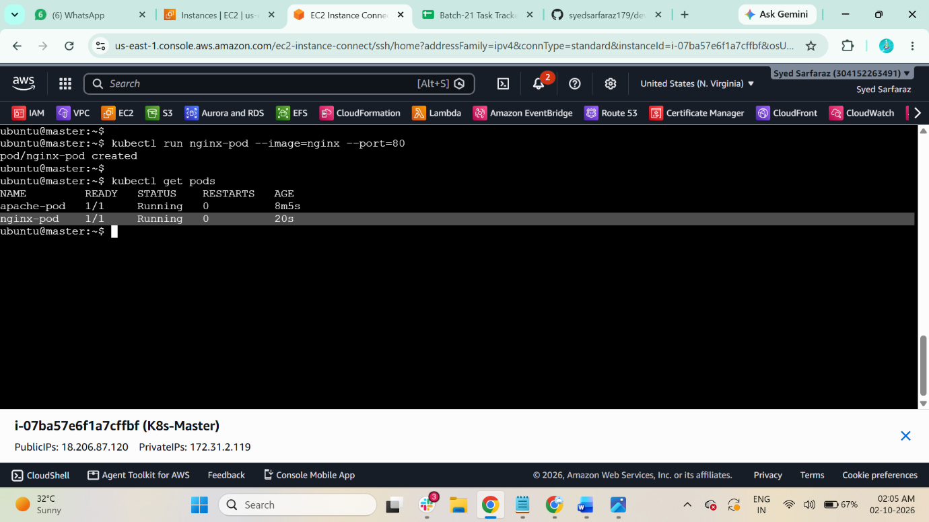

2. Check the Pod
kubectl get pods

3. Create NodePort Service
kubectl expose pod nginx-pod --name=nginx-service --port=80 --target-port=80 --type=NodePort
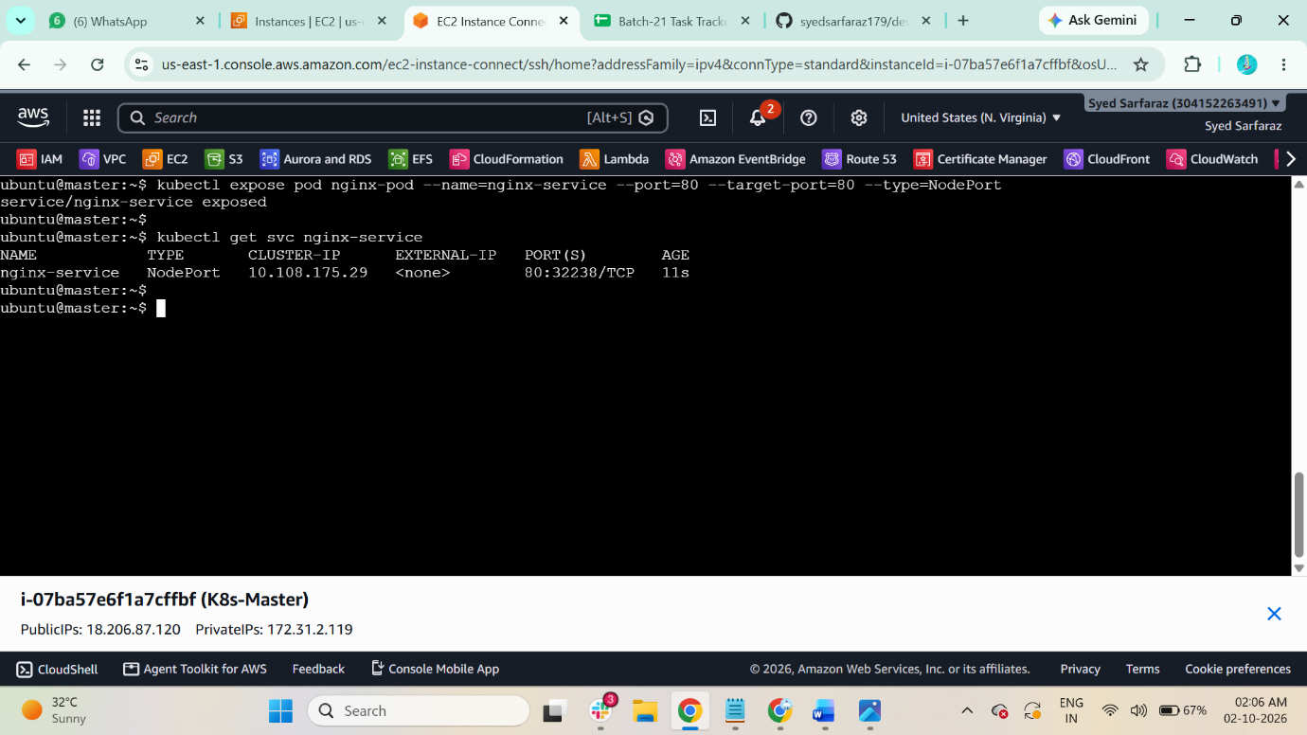

4. Check the Service and NodePort
kubectl get svc nginx-service

5. Get Node IP
kubectl get nodes -o wide
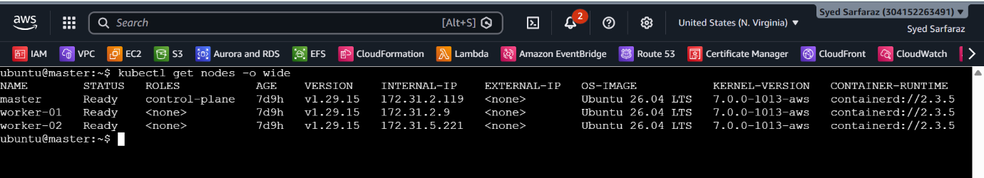

6. Access Nginx
Take worker-01 public-ip and run with port 32238
http://<NODE-IP>:<NODE-PORT>
Example:
http://192.168.1.10:30080
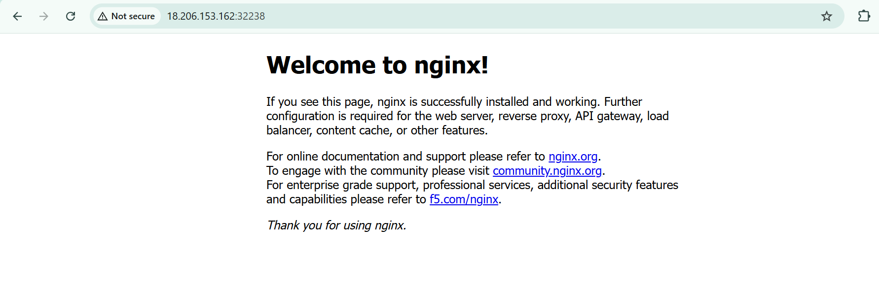

- Deploy a ReplicationController to maintain 3 replicas of an Nginx pod.

1. Create YAML file
nano nginx-rc.yaml

2. Add this configuration
apiVersion: v1
kind: ReplicationController
metadata:
name: nginx-rc
spec:
replicas: 3
selector:
app: nginx
template:
metadata:
labels:
app: nginx
spec:
containers:
- name: nginx
image: nginx
ports:
- containerPort: 80
Save: Ctrl+O → Enter → Ctrl+X
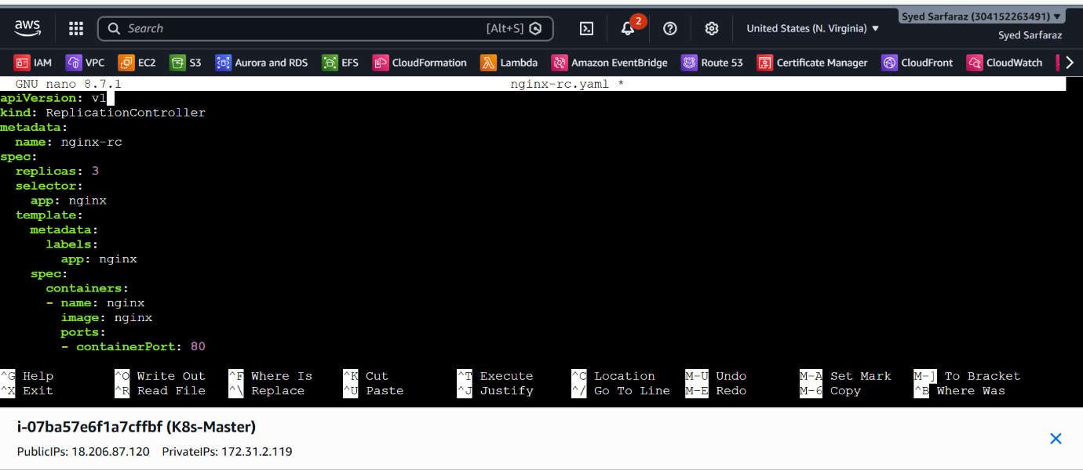

3. Create the ReplicationController
kubectl apply -f nginx-rc.yaml
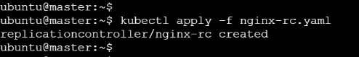

4. Verify
kubectl get rc
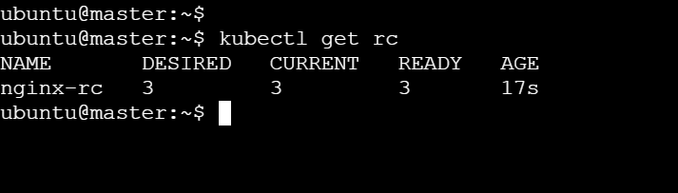

5. Check the 3 replicas
kubectl get pods -l app=nginx
You should see 3 Nginx pods in Running status.
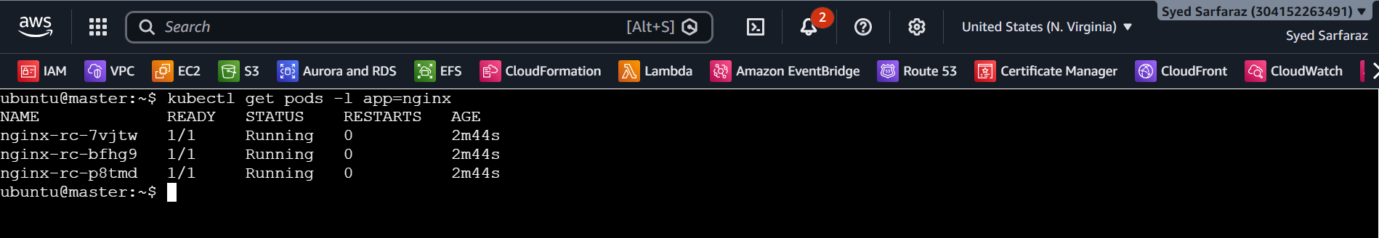

- Scale the Replication Controller from 3 replicas to 5 replicas.

1. Scale the ReplicationController
kubectl scale rc nginx-rc --replicas=5
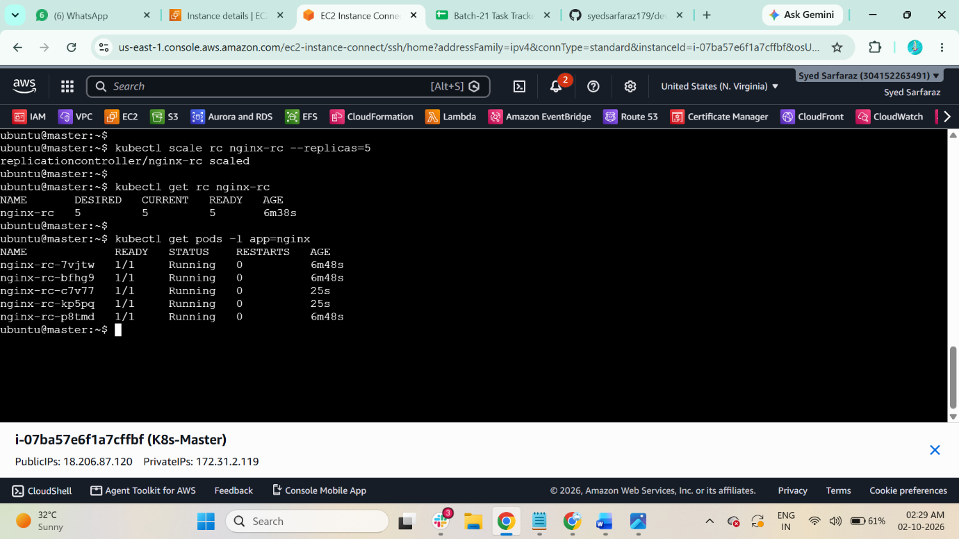

2. Verify
kubectl get rc nginx-rc
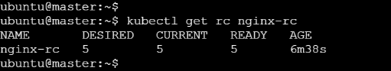

3. Check all 5 pods
kubectl get pods -l app=nginx
You should see 5 Nginx pods in Running status.

- Create a ReplicaSet to manage pods based on multiple labels (prod and test).

1. Create YAML file
$ Vi rs.yaml

2. Add this YAML
apiVersion: apps/v1
kind: ReplicaSet
metadata:
name: firstrc
labels:
appname: testapp

spec:
replicas: 2
selector:
matchExpressions:
- key: env
operator: In #value can be In or NotIn only
values:
- prod
- test
template:
metadata:
name: firstpod
labels:
env: prod
spec:
containers:
- name: firstcontainer
image: nginx
env:
- name: myname
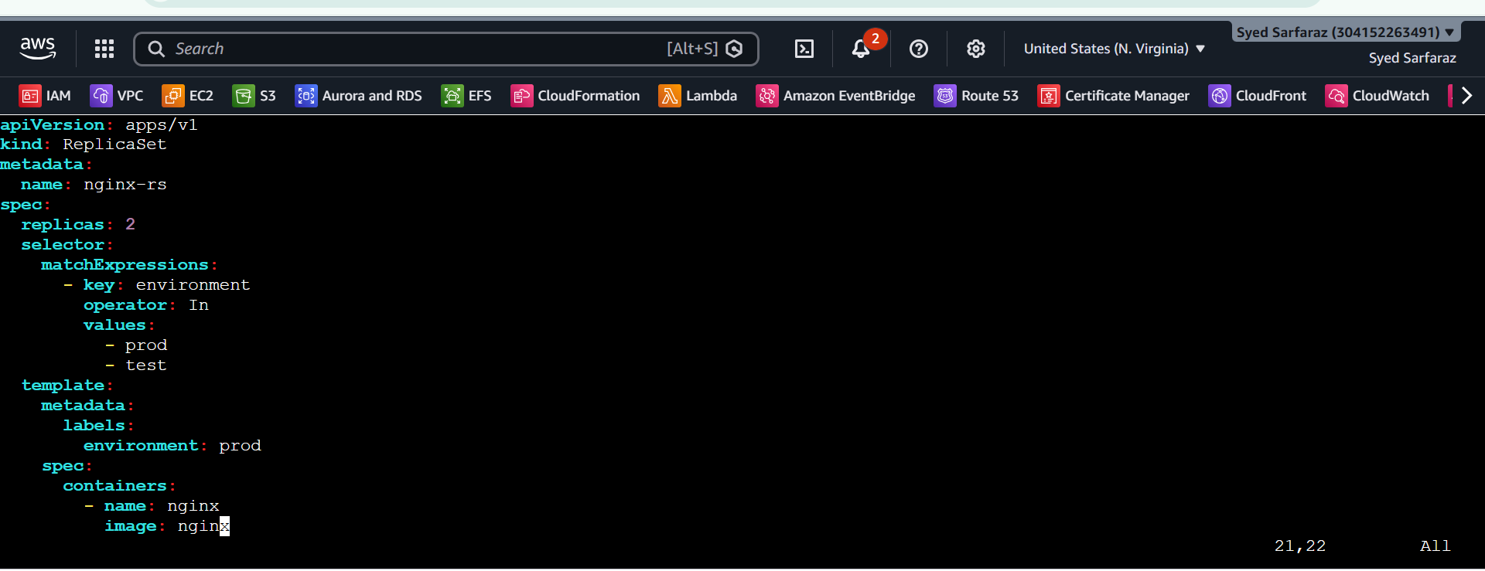

3. Apply the YAML
kubectl apply -f rs.yaml
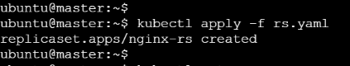

4. Verify ReplicaSet
kubectl get rs
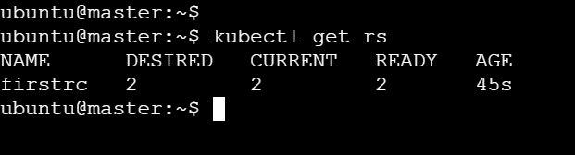

5. Verify Pods and labels
kubectl get pods --show-labels
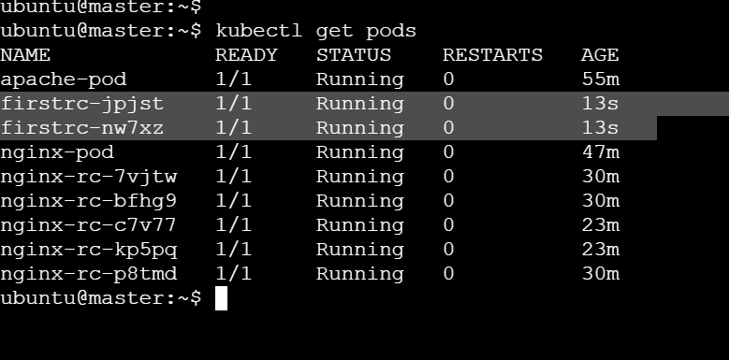

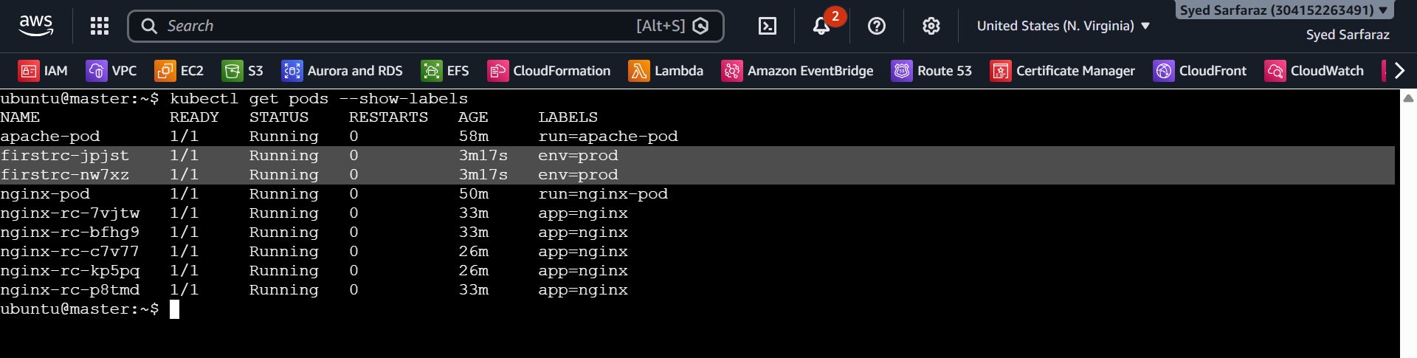

- Deploy a ReplicaSet that excludes pods with the label backend.

1. Create YAML file
vi rs- backend.yaml

2. Add:
apiVersion: apps/v1
kind: ReplicaSet
metadata:
name: exclude-backend-rs
spec:
replicas: 2
selector:
matchExpressions:
- key: app
operator: NotIn
values:
- backend
template:
metadata:
labels:
app: frontend
spec:
containers:
- name: nginx
image: nginx
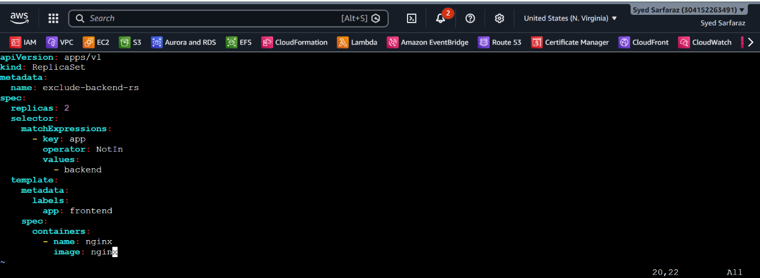

3. Apply
kubectl apply -f rs- backend.yaml
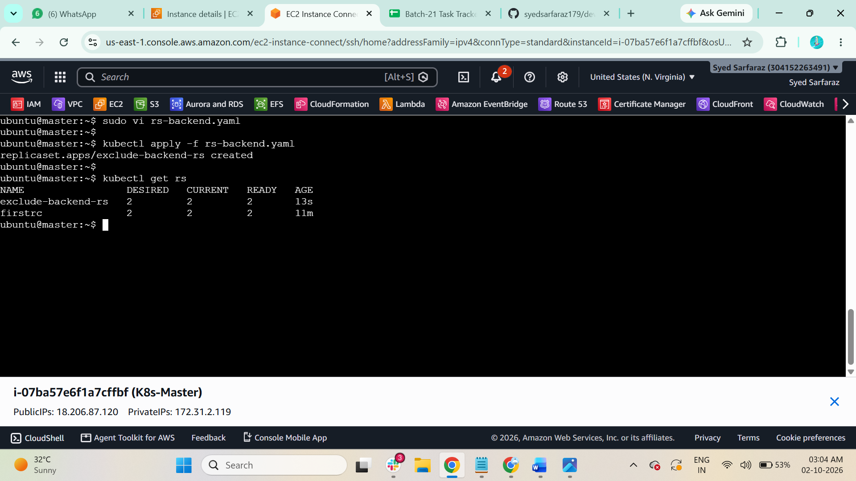

4. Verify
kubectl get rs

5. Check pod labels
kubectl get pods --show-labels
The ReplicaSet selector uses NotIn to exclude pods having app=backend.
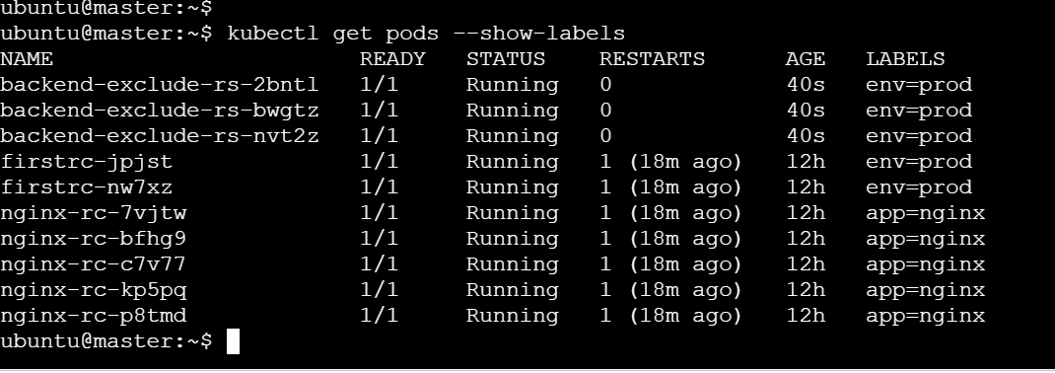

- Test load balancing across multiple pods using a NodePort service.

- 3 Nginx pods
- 1 HTTPD (Apache) pod
- A NodePort Service to expose them
- Then test whether requests are distributed across the pods.
1. Create 3 Nginx pods

Create nginx-pods.yaml:

apiVersion: v1
kind: Pod
metadata:
name: nginx-1
labels:
app: web
spec:
containers:
- name: nginx
image: nginx
ports:
- containerPort: 80
---
apiVersion: v1
kind: Pod
metadata:
name: nginx-2
labels:
app: web
spec:
containers:
- name: nginx
image: nginx
ports:
- containerPort: 80

---
apiVersion: v1
kind: Pod
metadata:
name: nginx-3
labels:
app: web
spec:
containers:
- name: nginx
image: nginx
ports:
- containerPort: 80
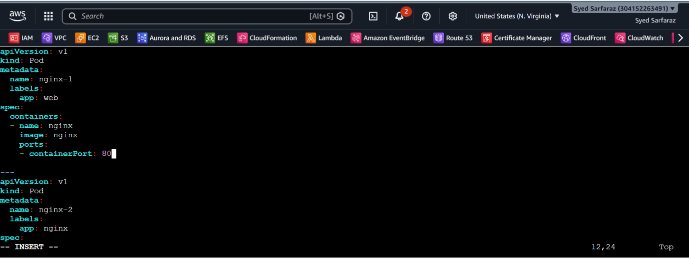
Apply:
kubectl apply -f nginx-pods.yaml
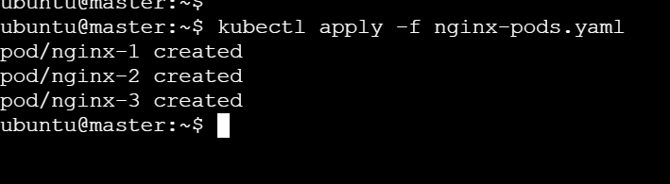
Check:
kubectl get pods -o wide
You should see:
nginx-1
nginx-2
nginx-3

2. Create 1 HTTPD pod
Create httpd-pod.yaml:

apiVersion: v1
kind: Pod
metadata:
name: httpd-1
labels:
app: web
spec:
containers:
- name: httpd
image: httpd
ports:
- containerPort: 80
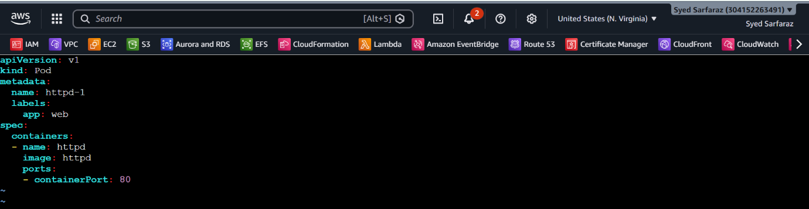

Apply:
kubectl apply -f httpd-pod.yaml
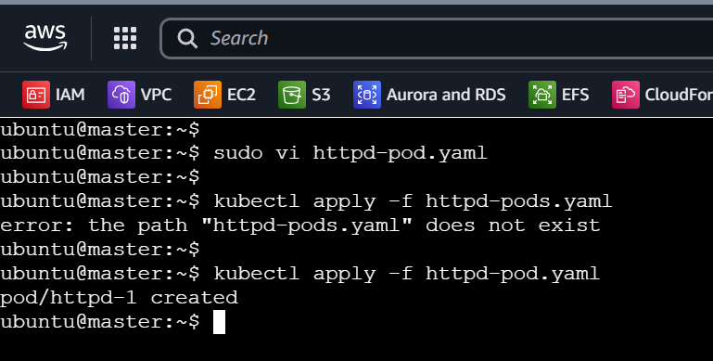

Check:
kubectl get pods
You should have:
nginx-1
nginx-2
nginx-3
httpd-1
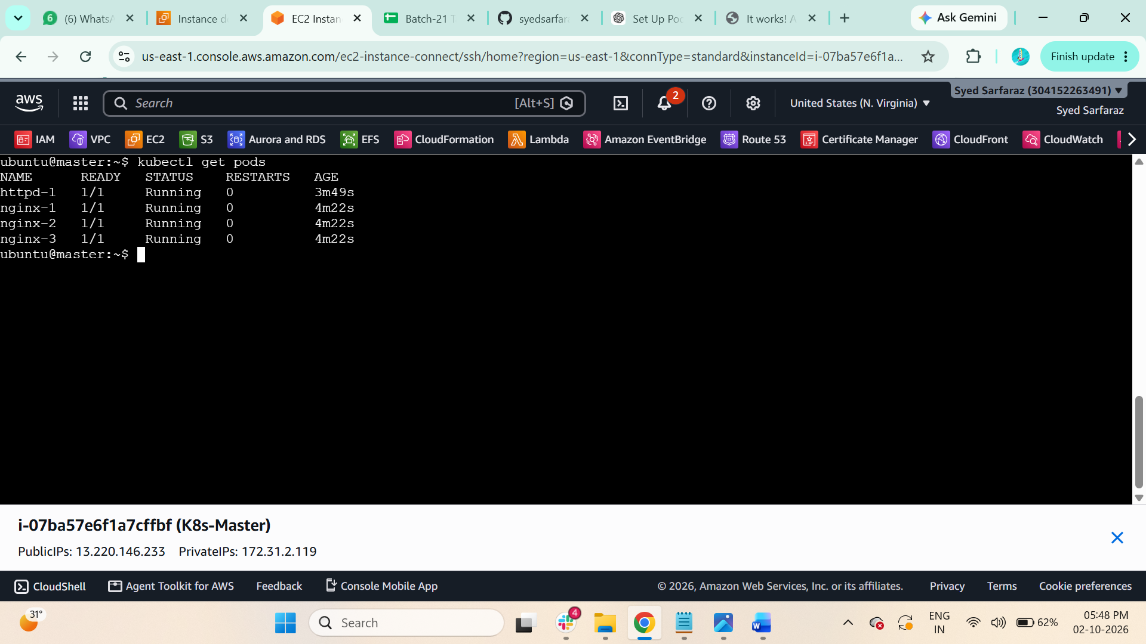

3. Create NodePort Service
For the load-balancing test, use only the 3 Nginx pods as service endpoints. The HTTPD pod should remain separate.

Create nginx-nodeport.yaml:

apiVersion: v1
kind: Service
metadata:
name: web-nodeport
spec:
type: NodePort
selector:
app: web
ports:
- port: 80
targetPort: 80
nodePort: 30080

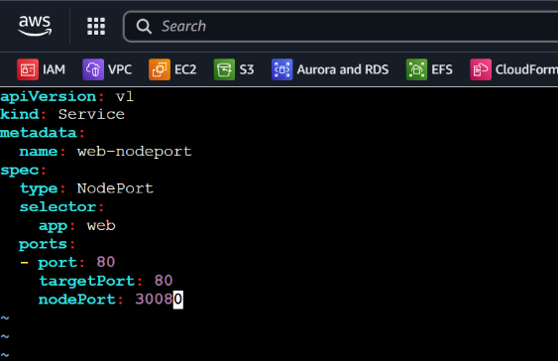

Apply:
kubectl apply -f nginx-nodeport.yaml
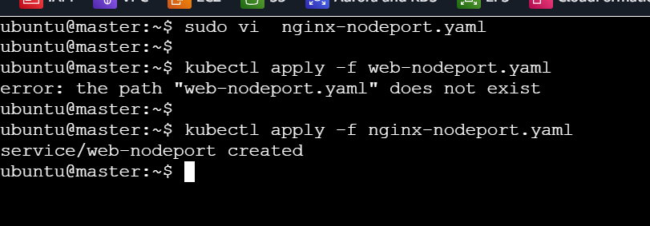

4. Check the Service
kubectl get svc
You should see something similar to:
nginx-nodeport NodePort ... 80:30080/TCP

Check which pods are behind the Service:
kubectl get endpoints nginx-nodeport
You should see 3 Nginx pod IP addresses.
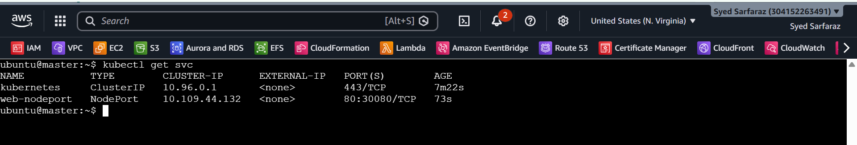

5. Test NodePort
If you are using your Kubernetes master/worker Ubuntu machines, get a node IP:
kubectl get nodes -o wide
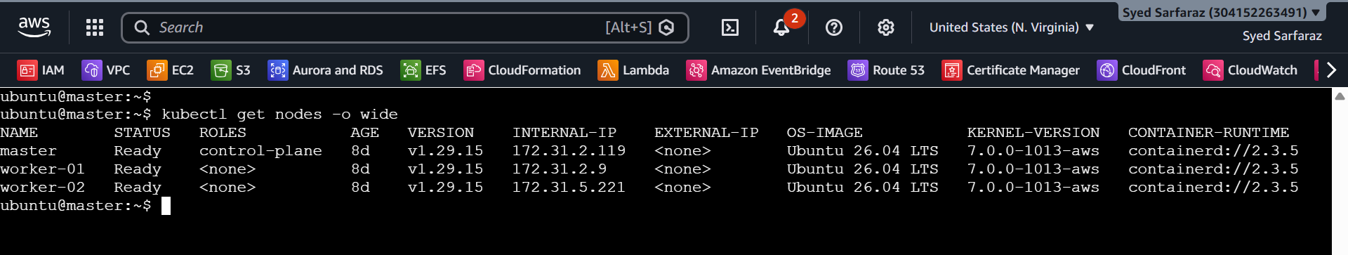

Verify all 4 endpoints
Run:
kubectl get endpoints web-nodeport
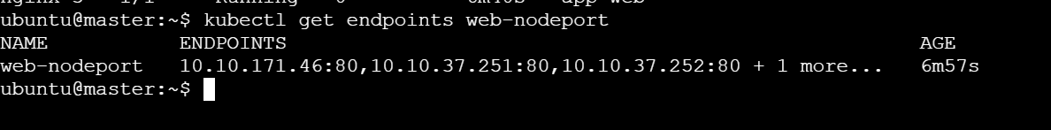
Also:
kubectl get pods --show-labels
All four should show:
app=web
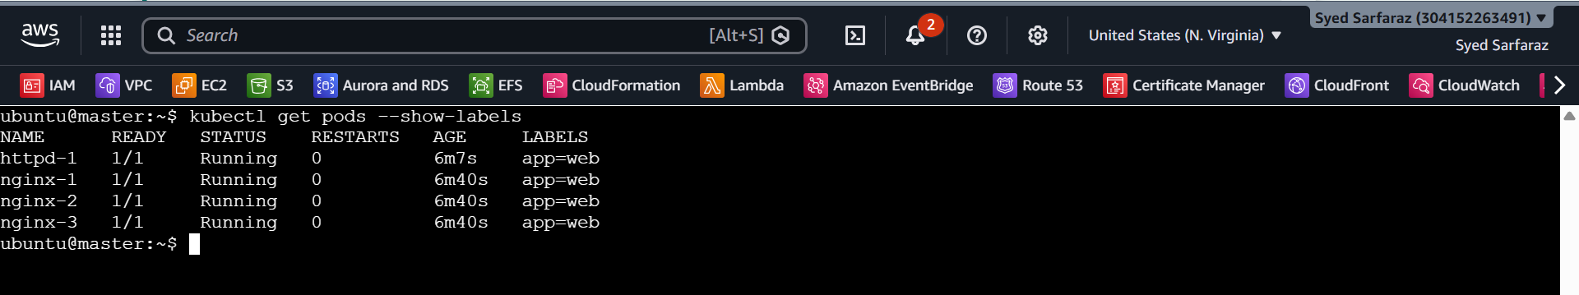
Make each pod return a different message
Nginx:
$ kubectl exec nginx-1 -- sh -c 'echo "NGINX POD 1" > /usr/share/nginx/html/index.html'

$ kubectl exec nginx-2 -- sh -c 'echo "NGINX POD 2" > /usr/share/nginx/html/index.html'

$ kubectl exec nginx-3 -- sh -c 'echo "NGINX POD 3" > /usr/share/nginx/html/index.html'

HTTPD:
$ kubectl exec httpd-1 -- sh -c 'echo "HTTPD POD 1" > /usr/local/apache2/htdocs/index.html'

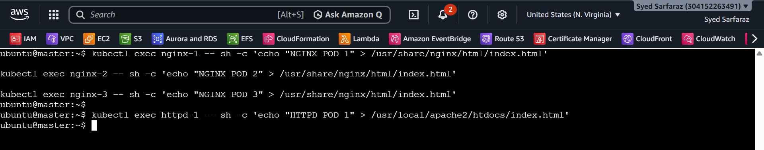

Then access:
http://<NODE-IP>:30080
For example:
http://44.222.236.5:30080

Response form nginx-pod
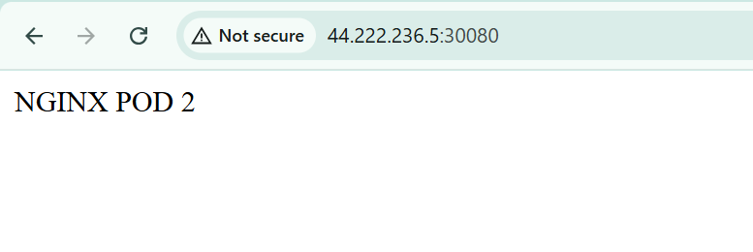
Response form httpd pod
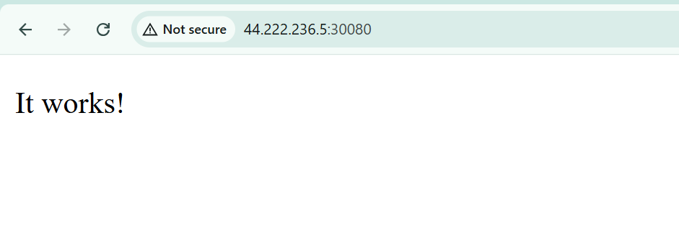

- Delete a Replication Controller without affecting the running pods.

Check the ReplicationController
kubectl get rc
You should see:
NAME DESIRED CURRENT READY
nginx-rc 3 3 3
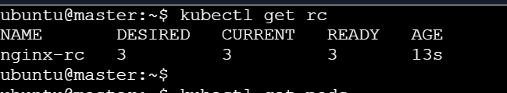

3. Check the running pods
kubectl get pods
You should have 3 Nginx pods.
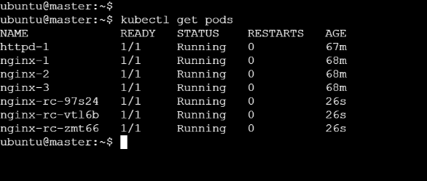

4. Delete the ReplicationController but keep the pods
This is the important command:
kubectl delete rc nginx-rc --cascade=orphan

--cascade=orphan means:
Delete the ReplicationController, but orphan/keep its pods running.
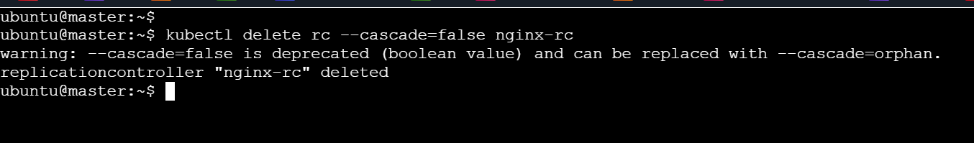

5. Verify the ReplicationController is deleted
kubectl get rc
nginx-rc should no longer appear.
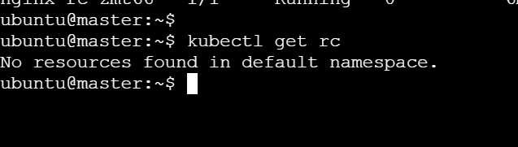

6. Verify the pods are still running
kubectl get pods
The 3 Nginx pods should still be running.
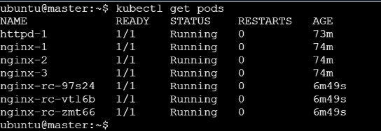

Final workflow
ReplicationController
|
| manages
v
nginx-pod-1
nginx-pod-2
nginx-pod-3
|
| kubectl delete rc nginx-rc --cascade=orphan
v
ReplicationController ❌ DELETED

Pods ✅ STILL RUNNING

